Guided Practice: Flow Diagram Examples

Below are three flow diagrams for students to interpret. Work in small groups to describe what each algorithm does in plain English.

## Flow Diagram 1: Add Two Numbers

This algorithm asks for two numbers, adds them, and outputs the result.

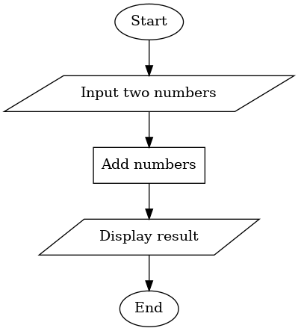

## Diagram 2: Check if Number is Even

This algorithm takes a number as input, checks if it is divisible by 2, and outputs 'Even' or 'Odd'.

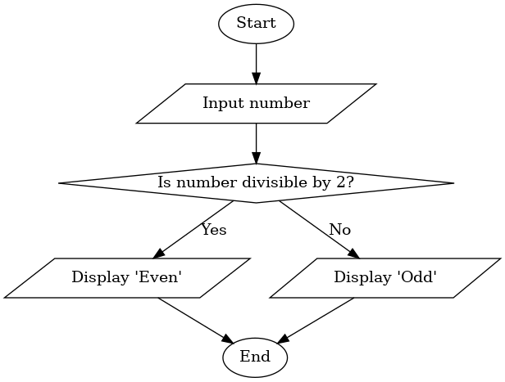

## Flow Diagram 3: Password Check Loop

This algorithm repeatedly asks for a password until the correct one is entered.

