Pioneers in Tech

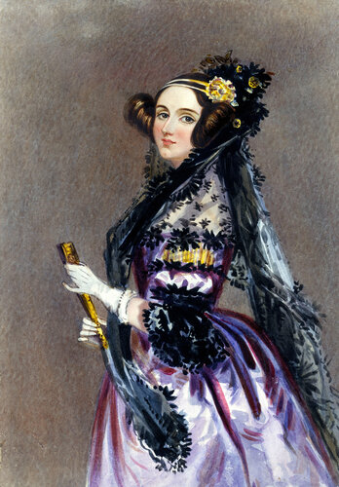  Ada Lovelace  Mathematician and writer  Wrote the first published algorithm intended for a computing machine, in her 1843 notes on Babbage's Analytical Engine. Foresaw that machines could process more than numbers alone. | 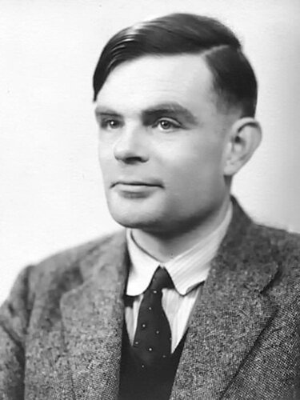  Alan Turing  Mathematician and codebreaker  Formalised the idea of a general-purpose computing machine in 1936. Helped break the Enigma cipher at Bletchley Park during WWII. Prosecuted in 1952 for being gay, under laws since repealed. | 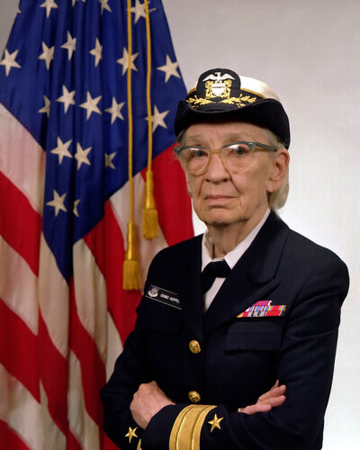  Grace Hopper  Computer scientist and Navy rear admiral  Wrote the first compiler and led the team behind FLOW-MATIC, which shaped COBOL. Served in the US Navy, retiring as a rear admiral. | 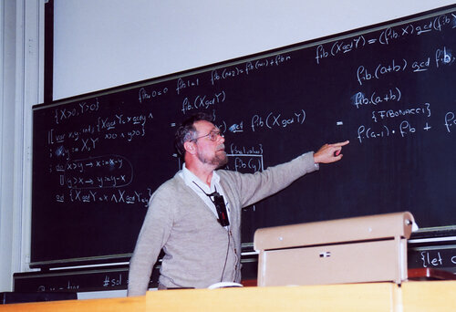  Edsger Dijkstra  Computer scientist  Devised the shortest-path algorithm that bears his name, now core to routing and navigation software. Championed structured programming over unrestrained use of goto. | 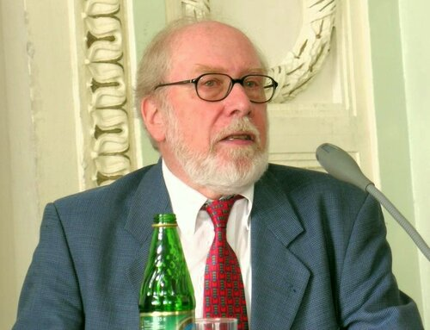  Niklaus Wirth  Swiss computer scientist  Designed Pascal in 1970 to teach structured programming, followed by Modula-2 and Oberon. Won the Turing Award in 1984.

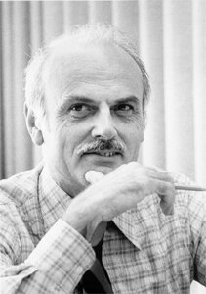  Edgar F. Codd  Computer scientist  Invented the relational model for databases at IBM in 1970, the theoretical basis for SQL and relational database systems everywhere. Won the Turing Award in 1981.  © Photo copyrighted (IBM) — fair use / educational display only. Not licensed for reprint or redistribution. | 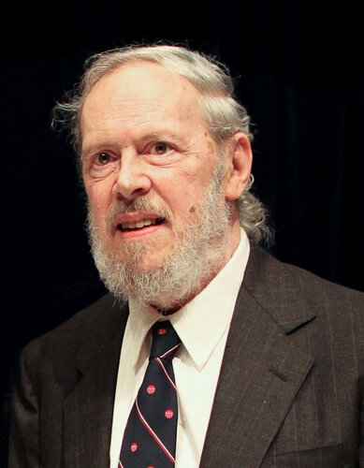  Dennis Ritchie  Computer scientist  Created the C programming language at Bell Labs and co-created Unix with Ken Thompson. Shared the 1983 Turing Award for that work. | 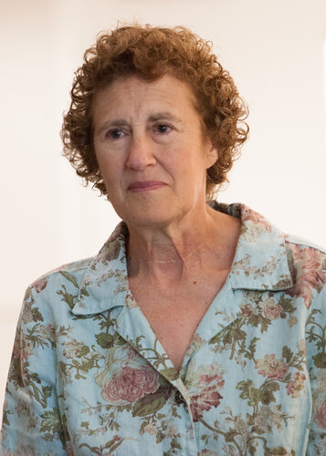  Barbara Liskov  Turing Award winning computer scientist  Built CLU, one of the first languages designed around data abstraction, and formulated the Liskov substitution principle. Second woman to win the Turing Award, in 2008. | 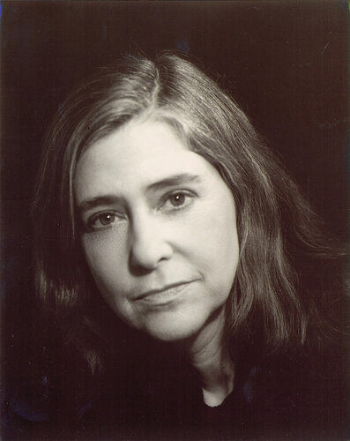  Margaret Hamilton  Software engineer  Led the team that wrote the Apollo Guidance Computer's flight software. Her error-handling code let Apollo 11 land safely despite a computer overload alarm. | 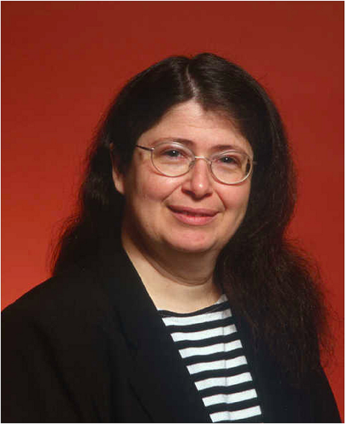  Radia Perlman  Inventor of the Spanning Tree Protocol  Wrote the protocol that stops loops in Ethernet networks, letting them scale from a few machines to hundreds of thousands. Holds over 100 patents.

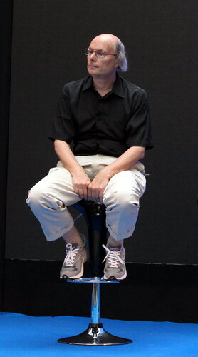  Bjarne Stroustrup  Creator of C++  Built C++ at Bell Labs from 1979, releasing it in 1985 as one of the first widely used object-oriented languages. | 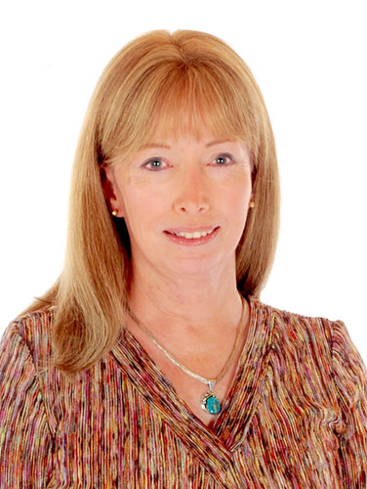  Lynn Conway  VLSI chip design pioneer  Made early contributions to computer architecture at IBM, then transformed chip design at Xerox PARC with her VLSI textbook. Fired by IBM in 1968 for being transgender; the company apologised in 2020. | 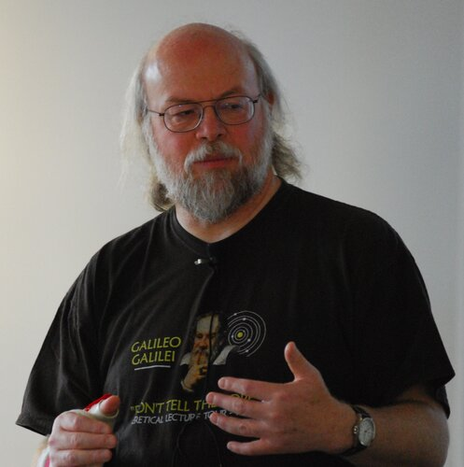  James Gosling  Canadian computer scientist  Led the team at Sun Microsystems that created Java in the early 1990s, now one of the world's most widely used programming languages. | 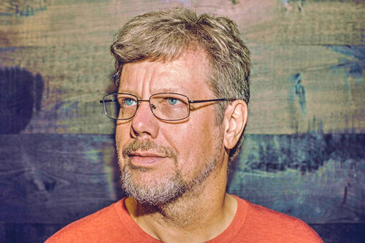  Guido van Rossum  Creator of Python  Built Python in 1990 at a Dutch research institute, first releasing it in 1991. Led the language's direction until stepping back in 2018. | 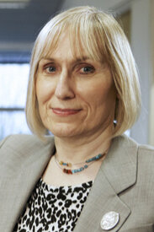  Sophie Wilson  Co-designer of BBC Micro and ARM  Wrote BBC BASIC and designed the BBC Micro's operating system at Acorn. Co-designed the original ARM instruction set, now behind most smartphones.

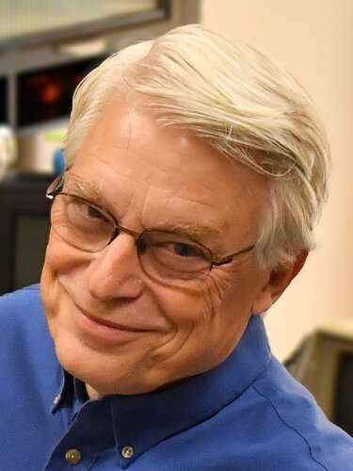  Robert C. Martin  Software engineer and author  Co-authored the Agile Manifesto and formulated the SOLID design principles. Wrote Clean Code, a standard reference on writing maintainable software. | 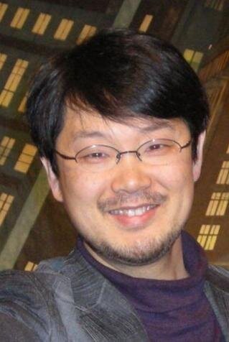  Yukihiro Matsumoto  Creator of Ruby  Designed the Ruby programming language, first released in 1995, blending ideas from Perl, Smalltalk and Lisp. Still leads its development. | 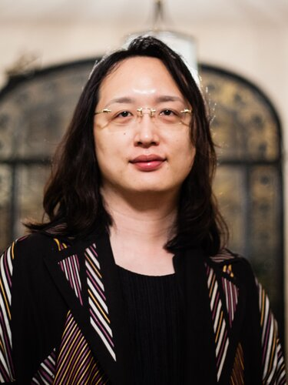  Audrey Tang  Civic hacker and digital minister  Became Taiwan's first Digital Minister in 2016. Built the real-time map of face mask stock during Covid-19. Taiwan's first openly transgender cabinet minister. | 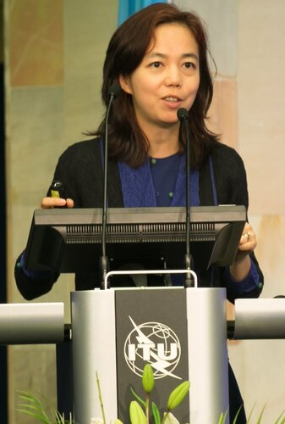  Fei-Fei Li  AI researcher and ImageNet creator  Built ImageNet, the labelled image dataset that helped trigger the deep learning boom. Co-founded Stanford's Human-Centered AI Institute. | 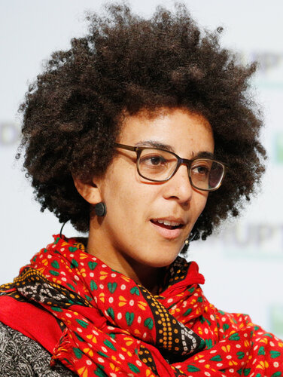  Timnit Gebru  AI ethics researcher  Co-founded Black in AI and later founded the Distributed AI Research Institute. Left Google in 2020 after a dispute over her research on AI risks.

Full biographies
Ada Lovelace — Mathematician and writer
Augusta Ada King, Countess of Lovelace (1815-1852). Worked with Charles Babbage on his proposed Analytical Engine and, in 1843, published an extended set of notes on it that included what is recognised as the first algorithm intended to be carried out by a machine. Her notes also anticipated that such a machine could work with things other than numbers, such as music, an early insight into general-purpose computing.
Alan Turing — Mathematician and codebreaker
Alan Mathison Turing (1912-1954). Formalised the concept of a general-purpose computing machine in 1936 with what is now called the Turing machine, laying the theoretical foundation for computer science. During WWII he worked at Bletchley Park, helping design the Bombe machine used to break the German Enigma cipher. In 1952 he was prosecuted under British law for homosexual acts, then illegal, and he died in 1954.
Grace Hopper — Computer scientist and Navy rear admiral
Grace Brewster Murray Hopper (1906-1992). Developed the first compiler, A-0, while working on the UNIVAC I, and led the team that created FLOW-MATIC, which influenced the design of COBOL. Served in the US Navy Reserve and later the Navy itself, retiring as a rear admiral, and is often credited with popularising the term 'debugging' after tracing a fault to a moth in a relay.
Edsger Dijkstra — Computer scientist
Edsger Wybe Dijkstra (1930-2002). Devised Dijkstra's algorithm for finding the shortest path between nodes in a graph, still widely used in routing and network applications. A leading advocate of structured programming, notably arguing against unrestricted use of the goto statement, and made foundational contributions to concurrent programming, including the semaphore.
Niklaus Wirth — Swiss computer scientist
Niklaus Emil Wirth (b. 1934). Designed the Pascal programming language in 1970 as a tool for teaching structured programming, and went on to design several successor languages including Modula-2 and Oberon. Received the Turing Award in 1984 for his contributions to programming language design.
Edgar F. Codd — Computer scientist
Edgar Frank 'Ted' Codd (1923-2003). Invented the relational model for database management while working at IBM, publishing the seminal paper 'A Relational Model of Data for Large Shared Data Banks' in 1970. His work established the theoretical basis for relational database systems and languages such as SQL.
Dennis Ritchie — Computer scientist
Dennis MacAlistair Ritchie (1941-2011). Created the C programming language at Bell Labs in the early 1970s, which went on to influence most modern programming languages and remains widely used for systems programming. Together with Ken Thompson, he co-created the Unix operating system, and the two shared the Turing Award in 1983.
Barbara Liskov — Turing Award winning computer scientist
Barbara Liskov (b. 1939). Developed the CLU programming language in the 1970s, one of the first languages built around data abstraction and abstract data types. Formulated the Liskov substitution principle, a rule for how subtypes should behave in object-oriented programming. Won the 2008 Turing Award, becoming only the second woman to receive it.
Margaret Hamilton — Software engineer
Margaret Heafield Hamilton (b. 1936). Led the team at MIT's Instrumentation Laboratory that developed the on-board flight software for NASA's Apollo Guidance Computer. Her error-handling code allowed the Apollo 11 guidance computer to recover from an overload alarm during the lunar landing and keep running, and she is credited with helping establish 'software engineering' as a discipline.
Radia Perlman — Inventor of the Spanning Tree Protocol
Radia Perlman (b. 1951). Invented the Spanning Tree Protocol while working at Digital Equipment Corporation, writing its specification in a matter of days. The protocol let Ethernet networks scale from a few hundred nodes in one building to hundreds of thousands of computers by preventing loops in network topology. Holds more than 100 patents.
Bjarne Stroustrup — Creator of C++
Bjarne Stroustrup (b. 1950). Began developing C++ (initially called 'C with Classes') at Bell Labs in 1979, releasing it generally in 1985 as one of the first widely used object-oriented programming languages. Wrote 'The C++ Programming Language', a reference book used by generations of programmers.

Lynn Conway — VLSI chip design pioneer
Lynn Conway (1938-2024). Made foundational contributions to computer architecture at IBM in the 1960s but was fired in 1968 after telling the company she was transitioning; IBM publicly apologised in 2020. At Xerox PARC in the 1970s she co-authored 'Introduction to VLSI Systems' with Carver Mead, a textbook that transformed how computer chips were designed, and she developed the rapid chip-prototyping system that became MOSIS.
James Gosling — Canadian computer scientist
James Arthur Gosling (b. 1955). Created the Java programming language while working at Sun Microsystems, leading the team that developed it in the early 1990s and writing the original Java compiler and virtual machine specification. Java went on to become one of the most widely used programming languages in the world.
Guido van Rossum — Creator of Python
Guido van Rossum (b. 1956). Created the Python programming language in 1990 while working at Centrum Wiskunde & Informatica in Amsterdam, first releasing it publicly in 1991. Served as Python's 'Benevolent Dictator for Life,' holding final authority over language design decisions, until stepping down from that role in 2018.
Sophie Wilson — Co-designer of BBC Micro and ARM
Sophie Wilson (b. 1957). Designed the operating system and wrote the BBC BASIC interpreter for the BBC Microcomputer at Acorn Computers in 1981. With colleague Steve Furber, co-designed the instruction set for the ARM processor, first produced in 1985, which became the basis for the architecture used in most of the world's smartphones today. Wilson is a transgender woman.
Robert C. Martin — Software engineer and author
Robert Cecil Martin, known as 'Uncle Bob' (b. 1952). Co-authored the Agile Manifesto in 2001 and formulated the SOLID principles of object-oriented software design. Wrote the widely used programming books 'Clean Code' and 'The Clean Coder', which set out practices for writing maintainable software.
Yukihiro Matsumoto — Creator of Ruby
Yukihiro 'Matz' Matsumoto (b. 1965). Designed the Ruby programming language, conceived in 1993 and first released in 1995, combining features from Perl, Smalltalk, Eiffel, Ada and Lisp. Wrote the original reference implementation, known as Matz's Ruby Interpreter, and continues to lead the language's ongoing development.
Audrey Tang — Civic hacker and digital minister
Audrey Tang (b. 1981). Contributed to the design of programming languages including Perl 6 and Haskell before becoming Taiwan's first Digital Minister in 2016. Built open civic-tech platforms and, during the Covid-19 pandemic, created a system that mapped real-time face mask stock levels at every pharmacy in Taiwan. Tang is openly non-binary and transgender, and was the first openly transgender minister in Taiwan's cabinet.
Fei-Fei Li — AI researcher and ImageNet creator
Fei-Fei Li (b. 1976). Led the creation of ImageNet, a database of millions of labelled images built from 2007 to 2009, and used it to run annual computer vision competitions that helped drive the deep learning boom of the 2010s. Directed the Stanford Artificial Intelligence Laboratory and co-founded Stanford's Human-Centered AI Institute.
Timnit Gebru — AI ethics researcher
Timnit Gebru (b. 1983). Co-founded Black in AI in 2017 to increase the presence of Black researchers in artificial intelligence, and later founded the Distributed AI Research Institute (DAIR). Co-wrote a widely cited paper on the risks of large language models while co-leading Google's Ethical AI team, and left the company in December 2020 amid public controversy over the paper.

Image sources and licensing
All portraits are sourced from Wikimedia Commons and are public domain or Creative Commons licensed, except Edgar F. Codd's, which is copyrighted (credit IBM) and included here under fair use for educational purposes only — it must not be reprinted or redistributed without separate permission from the rights holder.
Name | Image source URL | Licence / attribution
Ada Lovelace | https://upload.wikimedia.org/wikipedia/commons/a/a4/Ada_Lovelace_portrait.jpg | Public domain
Alan Turing | https://upload.wikimedia.org/wikipedia/commons/f/f8/Alan_Turing_(1951).jpg | Public domain
Grace Hopper | https://upload.wikimedia.org/wikipedia/commons/a/ad/Commodore_Grace_M._Hopper,_USN_(covered).jpg | Public domain (US Navy photo)
Edsger Dijkstra | https://upload.wikimedia.org/wikipedia/commons/c/c9/Edsger_Dijkstra_1994.jpg | CC BY-SA 4.0, photo by Andreas F. Borchert
Niklaus Wirth | https://upload.wikimedia.org/wikipedia/commons/4/49/Niklaus_Wirth,_UrGU.jpg | Copyrighted free use (permitted per Commons file page)
Edgar F. Codd | https://upload.wikimedia.org/wikipedia/en/5/58/Edgar_F_Codd.jpg | COPYRIGHTED - fair use only, credit IBM
Dennis Ritchie | https://upload.wikimedia.org/wikipedia/commons/2/23/Dennis_Ritchie_2011.jpg | CC BY 2.0
Barbara Liskov | https://upload.wikimedia.org/wikipedia/commons/3/38/Barbara_Liskov_MIT_computer_scientist_2010.jpg | CC BY-SA 3.0
Margaret Hamilton | https://upload.wikimedia.org/wikipedia/commons/6/68/Margaret_Hamilton_1995.jpg | CC BY-SA 3.0, photo by Daphne Weld Nichols
Radia Perlman | https://upload.wikimedia.org/wikipedia/commons/0/0b/Radia_Perlman.png | CC BY-SA 2.0 (Intel Free Press)
Bjarne Stroustrup | https://upload.wikimedia.org/wikipedia/commons/f/ff/Bjarne_Stroustrup_(26095952203).jpg | CC BY 2.0
Lynn Conway | https://upload.wikimedia.org/wikipedia/commons/5/50/Lynn_Conway_July_2006.jpg | CC BY-SA 2.5
James Gosling | https://upload.wikimedia.org/wikipedia/commons/1/14/James_Gosling_2008.jpg | CC BY-SA 4.0, photo by Peter Campbell
Guido van Rossum | https://upload.wikimedia.org/wikipedia/commons/e/e2/Guido-portrait-2014-drc.jpg | CC BY-SA 4.0, photo by Dan Stroud
Sophie Wilson | https://upload.wikimedia.org/wikipedia/commons/b/be/Sophie_Wilson_(cropped).jpg | CC BY 2.0
Robert C. Martin | https://upload.wikimedia.org/wikipedia/commons/4/47/Robert_C._Martin_surrounded_by_computers_(cropped).jpg | CC BY-SA 4.0, photo by Angelacleancoder
Yukihiro Matsumoto | https://upload.wikimedia.org/wikipedia/commons/7/76/Yukihiro_Matsumoto.JPG | Public domain
Audrey Tang | https://upload.wikimedia.org/wikipedia/commons/f/fe/Audrey_tang_089_(25378300354)_(cropped).jpg | CC0 1.0 (public domain dedication)
Fei-Fei Li | https://upload.wikimedia.org/wikipedia/commons/c/c7/Fei-Fei_Li_at_AI_for_Good_2017.jpg | CC BY 2.0
Timnit Gebru | https://upload.wikimedia.org/wikipedia/commons/6/6d/Timnit_Gebru_crop.jpg | CC BY 2.0

